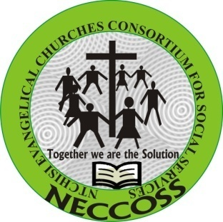
YOUTH ECONOMIC EMPOWERMENT (YEE) END OF PROJECT REPORT
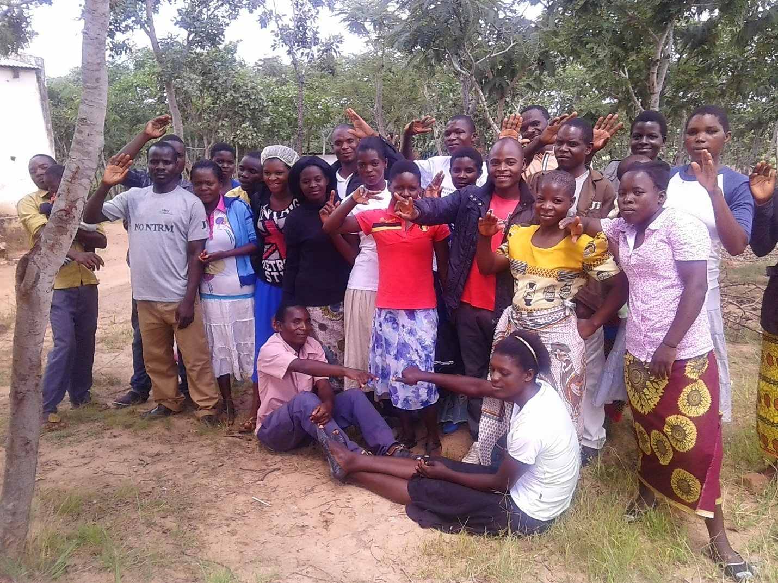
Malenga Youth club posing for a photograph after enjoying the YEE project meeting

Reporting period: December, 2017 - November, 2018 (12 months)

Reference: Mathias Chindungwa. Email: neccoss79@gmai.com Cell: +265999355541

Table of contents Pages
Cover page……………………………………………………………………………………………………………...1
Table of contents……………………………………………………………………………………………………….3
Introduction……………………………………………………………………………………………………………..3
Major highlights ………………………………………………………………………………………………………..4
Target achievements/outcomes……………………………………………………………………………………4-6
Narration for each activity…………………………………………………………………………………………7-11
Sustainability………………………………………………………………………………………………………….11
Narration achievement, Lessons and Challenges ……………………………………...……………………11-12
Success Stories…………………………………………………………………………………………………..12-13

- Introduction
In Malawi about 13 of 18 million of the population is in the age between 0-24years which constitute 66 percent of the whole population. Out of these, it is estimated that the Youth unemployment rate, which in this case refers to the share of the labor force ages 15-24 without work but available for and seeking employment is at 9.1 percent. Additionally, it is estimated that 90% of the youth do not have the necessary skills or training required for professional employment. (Malawi Youth status report 2016)
The project intended to equip the youth by providing them with necessary skills and knowledge needed for producing quality products and services through theory and hands on technical training in various fields and thereafter providing them with startup resources that will enable them to create businesses. The project overall goal was to empower youth economically and remain self-reliant through develop and strengthen the capacity of the 120 youth in Ntchisi for job creation by November, 2018 and the following were broad activities put in place to address the challenges mentioned above.
- Organizing training workshops for youth in entrepreneurship to expose them to modern skills needed for business management and creation.
- Organize training for specific hands on technical skills in different fields.
- Mobilize youth in VSL and provide loans (cash and livestock production).
The project started in December, 2017 and by now we have reached 304 youth (157 males and 147 females) through 12 youth clubs in 4 Traditional Authorities (T/As) namely Malenga, Kalumo, Chilooko and Vusojere. Most of the youth targeted are aged from 10-35 and these are both in school and out school youth.At first 24 youth clubs were given and visited however after assessing them all, we selected 12 youth clubs to benefit first from the project.
The project total cost was15 million Malawi Kwacha for 12 months supported by Eiviend from Norway.
2.1 Overall project Goal
To empower youth economically and remain self-reliant through develop and strengthen the capacity of the 120 youth in Ntchisi for job creation by November, 2018
2.2 Project Purpose
The project intended to equip the youth by providing them with necessary skills and knowledge needed for producing quality products and services through theory and hands on technical training in various fields and thereafter providing them with startup resources that will enable them to create businesses.
2.3 Specific Objectives
- To facilitate savings facility (VSL), provide business management and entrepreneurship skills for 120 youth by November, 2018
- To support 12 youth trained on technical various fields that are viable in their areas and thereafter providing them with startup resources by November, 2018
- To provide loans to 60 youth (cash as revolving fund) or (livestock as pass on program) including agricultural loan and promote sporting activities targeting 12 youth clubs by November, 2018

- Major highlights
- Briefing meeting about the project with Youth Technical Sub-committee (YTSC)
- Briefing meeting about the project with None State Actors (NSAs)
- Briefing meeting about the project with District Executive Committee (DEC)
- Sensitization meetings with Area Development Committees, church leaders and Youth networks
- Conduct Youth clubs meetings about the project and assessment for selection.
- Youth trainings in VSL, business management and entrepreneurship skills
- Provision of soft loans (Cash) to selected youth members to start small scale businesses
- Youth trainings on technical various fields at Mponela Technical Community College
- Project close out meeting with key stakeholders meeting at district level

- Achievements/Outcomes
In the table below are all the activities mentioned above summarized on how the activities were conducted by looking on what was planned against the results or what is achieved.
Activity | Target |  |  | Immediate Result/changes |  |  | comments
 | unit | plan | Achieved | % Achieved | Expected | Actual
YTSC meeting | meetings | 1 | 1 | 100 | 1meeting conducted.  21members reached | 1 meeting conducted.  21 YTSC members (15 males and 6 females) reached. | Expected targets achieved and technical support provided
NSAs meeting | Meetings | 1 | 1 | 100  95 | 1meeting conducted.  20members reached | 1 meeting conducted  19 NSA members (10 males and 9 females reached | Expected targets not achieved because of apologies from 1 NGO however project technical support increased
DEC meeting including additional 1 additional ADC members | Meetings | 1 | 1 | 100 | 1meeting conducted  60 DEC members reached | 1 meeting conducted  60 DEC members reached | Expected targets achieved and the DEC welcome the project with depth technical support
Area Development committee, Church leaders and Youth network meetings | Meetings | 3 | 4 | 133 | 3meetings conducted.  120 participants | 4 meetings conducted  160 participants (71 males and 89 females) | Expected targets over achieved and list of youth clubs to visit for assessment and selection were given.
Youth clubs visit for assessment and selection | visits | 24 | 24 | 100  100  253 | 24 youth clubs visited.  12 youth clubs selected  120 youth members | 24 youth clubs visited  12 youth clubs selected  304 youth members (157 males and 147 females) reached | Expected targets achieved, 12 youth clubs selected and all the selected youth clubs were sensitized to start VSL activities.
Youth trained in VSL, business management and entrepreneurship skillsẁ | trainings | 12 | 12 | 100  167 | 12 trainings conducted and 12 youth clubs reached  120 youth members trained | 12 trainings conducted and 12 youth youth clubs reached  200 youth members trained (110 males and 90 females) | The target achieved as expected  Expected targets over achieved because of increased youth members in clubs.
Provision of Soft loans (Cash) to selected youth to start small scale businesses. | Loans | 1 | 1 | 100 | 60 youth members received loans amounting to 2 million Malawi Kwacha | 60 youth members (42 boys and 18 girls) received loans amounting to 2 Million Malawi kwacha and started small scale businesses | The target achieved as expected
Youth trained on technical various fields at Mponela Technical Community College | trainings | 1 | 1 | 108 | 12 youth members trained | 13 youth members trained  (9 boys and 4 girls) | Expected targets over achieved because the resources was available to increase the target with 1 person.
Project close out meeting with key stakeholders meeting at district level | meeting | 1 | 1 | 100 | 15 youth members briefed on the results of the project and plan for way forward | 15 youth members (9 males and 6 females) briefed on the results of the project and plan for way forward | The target achieved as expected

- Narration of the activities
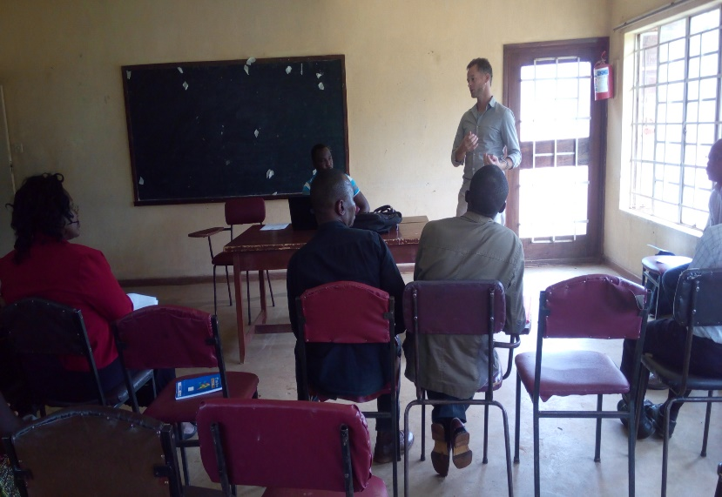
5.1 Youth Technical Sub-Committee (YTSC) meeting The purpose of the meeting was to introduce the project to members of YTSC at district level and conduct mapping exercise so that we are able to identify potential partners and some of them identified included; YONECO, Save the children, Action aid and Ntchisi organization for Youth and Development to mention a few. It was the first good meeting for us and we were helped to visit the project document again by including some facts for example; the criteria put in place to select the impact area of the project and beneficiaries was not coming clear in the first paper work and we were directed to use the vulnerability assessment report for youth in the T/As. About 21 participants (15 males and 6 females) attended the meeting and it took place in December, 2017 at District Community Development Offices in Ntchisi.
  - None State Actors meeting
This was the second activity and it took place in January, 2018 at NICE offices. Mainly participants to the meeting were NGOs. In Ntchisi we have a network of NGOs and with powers invested in the network through the MOU that was developed between the NGOs and district council states that any new projects by NGOs should be presented to this network before DEC for easy coordination of programs and avoid duplication of efforts in the same impact areas. About 19 NGOs (10 males and 9 females) attended the meeting and by the end of the meeting we were also to know who is doing what in the district and the network strengthened through sharing a common goal especially on youth economic empowerment activities.
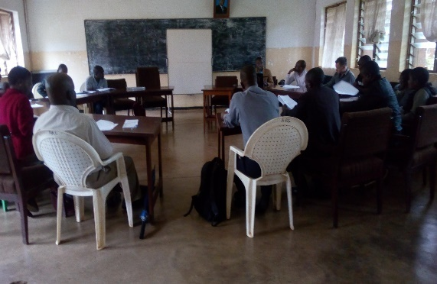
  - District Executive Committee (DEC) meeting
It took place at Agriculture conference hall in Ntchisi district and that was in February, 2018. About 60 DEC members (46 males and 14 females) attended the meeting. It was also fruitful meeting taking into consideration that the meeting was full involved with government heads of department including District planning and development officer. The DEC supported the project idea that it was sounding vibrant to address the challenges that youth are facing especially lack of vocational skills, limited access to loans and in adequate knowledge in business management and entrepreneurship skills. It was also mentioned to make sure that girls and youth with disabilities benefit from the project. The initial plan was to go with the project in three T/As namely Malenga, Kalumo and Chilooko but after presenting this to DEC we were asked to include Vusojere area simply because most of the youth in that area are sidelined not to benefit from many developments compared to other areas on the same.
  - Area Development Committee (ADC), Church leaders and Youth networks meetings
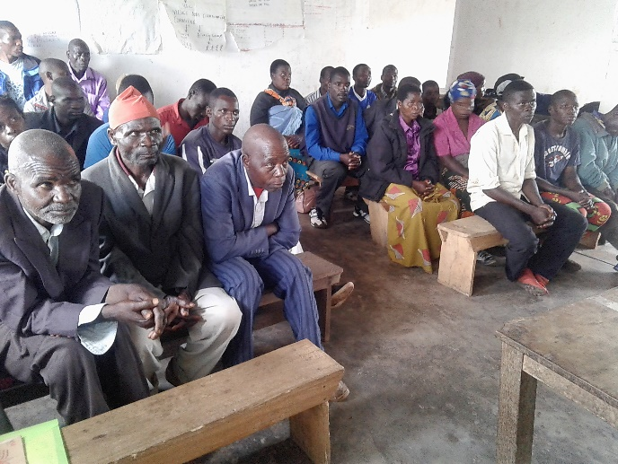
ADC, Church leaders and Youth networks were sensitized in all 4 Traditional Authorities and 160 people (71 males and 81 females) reached and aware of the project. The ADC and other groups contributed a lot to smooth running of the project by giving us a list of 24 well-established youth clubs so that we go to visit and assess them for selection if they stand to be the first to benefit from the project or not and in the end 12 youth clubs only selected. The three groups (ADC, church leaders and youth networks) promised to own the project through active participation and monitoring in all activities taking place in the communities. The meetings took place in March, 2018
  - Youth clubs visits for assessment and selection
As already mentioned above 12 clubs with membership of 173 youth (92 males and 81 females) selected and we have started working with them. The youth clubs were sensitized to start VSL activities. In each Traditional Authority (T/A) we are targeting 3 youth clubs adding to 12 in all 4 T/As. The exercise conducted in March, 2018. Most of the youth clubs were selected by looking or assessing them on the following;
- The youth club membership should be in the range from 10-35
- Registered with the District council and youth network
- Practicing VSL or ready to start
- Having other Income Generating Activities (IGAs) ie Gardens
- Taking part and supportive in community and church developments
- Some of the members should be economically active
- Age group 10-35
- Meeting days, place, time etc.

  - Youth trainings in VSL, business management and entrepreneurship skills
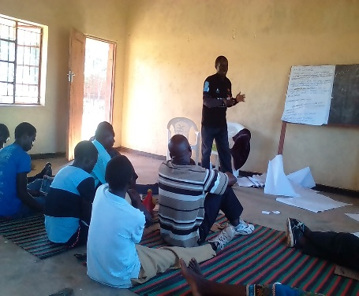
200 youth (110 boys and 90 girls) aged 18 to 35 were equipped with knowledge in VSL concept, business management and entrepreneurship skills. The initial plan was to reach 120 youth members but due to increased youth joining the clubs the project ended reaching 200 boys and girls. The training was community based and nonresidential. The facilitators were identified from District Community Development Office in Ntchisi district. In table below are the figures of boys and girls by name of clubs attended the trainings.
No | Youth club | Sex |  |  | Village | T/A
No | Youth club | M | F | Total
1 | Chitenje | 12 | 3 | 15 | Nyanga | Vusojere
2 | Mpika | 7 | 6 | 13 | chimwala | Vusojere
3 | Emnsunduzela | 9 | 3 | 12 | Vusojere | Vusojere
4 | Masokole | 13 | 5 | 18 | Masokole | Chilooko
5 | Chalenda | 10 | 8 | 18 | Ching’amba | Chilooko
6 | Dete | 11 | 8 | 19 | Dete | Chilooko
7 | Malenga | 10 | 14 | 24 | Malenga | Malenga
8 | Kaphwiti | 12 | 2 | 14 | Mtachira | Malenga
9 | Kamsonga | 5 | 8 | 13 | Kamsonga | Malenga
10 | Kawenda | 8 | 16 | 24 | Kawenda | Kalumo
11 | Kala | 5 | 8 | 13 | Chisoso | Kalumo
12 | Masophenya | 8 | 9 | 17 | Chabwinkha | Kalumo
 | Total | 110 | 90 | 200

  - Provision of soft loans (Cash) to selected youth members to start small scale businesses
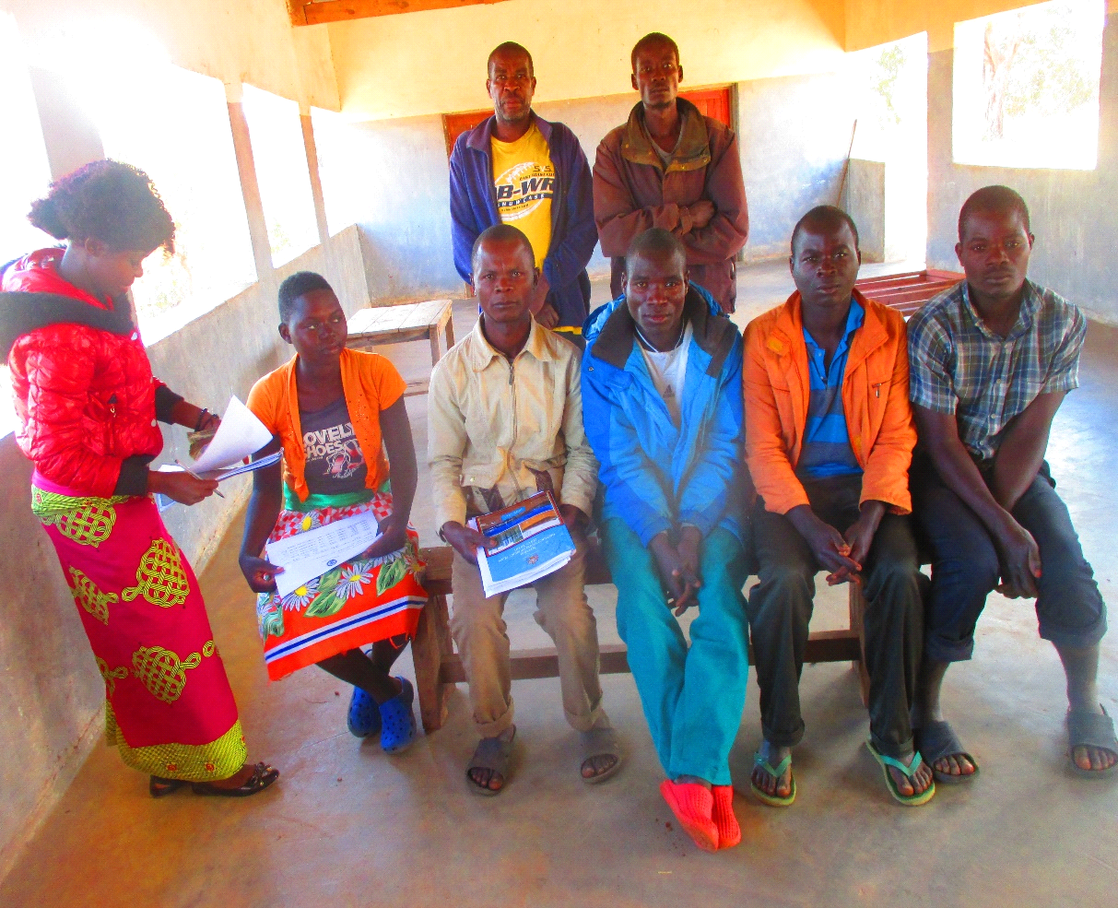60 beneficiaries (42 boys and 18 girls) provided with loans amounting to MK 2,000,000.00 to run different small scale business. In all the 12 youth clubs, 5 individuals in each club were selected to benefit for the first time and the other 5 also identified ready to benefit for the second time. Loan interest was 10% per month for 4 months and the interest was put to cover loan management and administration costs. The good thing is that youth have managed to pay back the total sum of Two million Malawi Kwacha invested in the soft loan program. This means the activity will be sustained to benefit more youth. Looking on the picture is the chalenda youth club phosing for a group photo after received loan. Below is the table showing all the clubs, number of youth in each club received loan, indication of principal amount of loan disbursed to each club and expected total amount of money for the youth beneficiaries to pay back after three to four months.
No | Youth club | Sex |  |  | LOAN | TOTAL INTEREST FOR 3 MONTHS | LOAN + TOTAL INTEREST | MONTHLY INSTALMENT | Village | T/A
No | Youth club | M | F | Total
1 | Chitenje | 3 | 2 | 5 | 160,000.00 | 48,000.00 | 208,000.00 | 69,385.00 | Nyanga | Vusojere
2 | Mpika | 3 | 2 | 5 | 160,000.00 | 48,000.00 | 208,000.00 | 69,385.00 | chimwala | Vusojere
3 | Emnsunduzela | 3 | 2 | 5 | 160,000.00 | 48,000.00 | 208,000.00 | 69,385.00 | Vusojere | Vusojere
4 | Masokole | 5 |  | 5 | 160,000.00 | 48,000.00 | 208,000.00 | 69,385.00 | Masokole | Chilooko
5 | Chalenda | 4 | 1 |  | 240,000.0 | 72,000.00 | 312,000.00 | 104,000.00 | Ching’amba | Chilooko
6 | Dete | 3 | 2 | 5 | 160.000.00 | 48,000.00 | 208,000.00 | 69,385.00 | Dete | Chilooko
7 | Malenga | 3 | 2 | 5 | 160,000.00 | 48,000.00 | 208,000.00 | 69,385.00 | Malenga | Malenga
8 | Kaphwiti | 5 |  |  | 160,000.00 | 48,000.00 | 208,000.00 | 69,385.00 | Mtachira | Malenga
9 | Kamsonga | 3 | 2 | 5 | 160,000.00 | 48,000.00 | 208,000.00 | 69,385.00 | Kamsonga | Malenga
10 | Kawenda | 4 | 1 | 5 | 160,000.00 | 48,000.00 | 208,000.00 | 69,385.00 | Kawenda | Kalumo
11 | Kala | 3 | 2 | 17 | 160.000.00 | 48,000.00 | 208,000.00 | 69,385.00 | Chisoso | Kalumo
12 | Masophenya | 3 | 2 | 30 | 160,000.00 | 48,000.00 | 208,000.00 | 69,385.00 | Chabwinkha | Kalumo
 | Total | 42 | 18 | 60 | 2,000,000 | 600,000.00 | 2,600.000 | 867,235.00

  - Youth trainings on technical various fields at Mponela Technical Community College
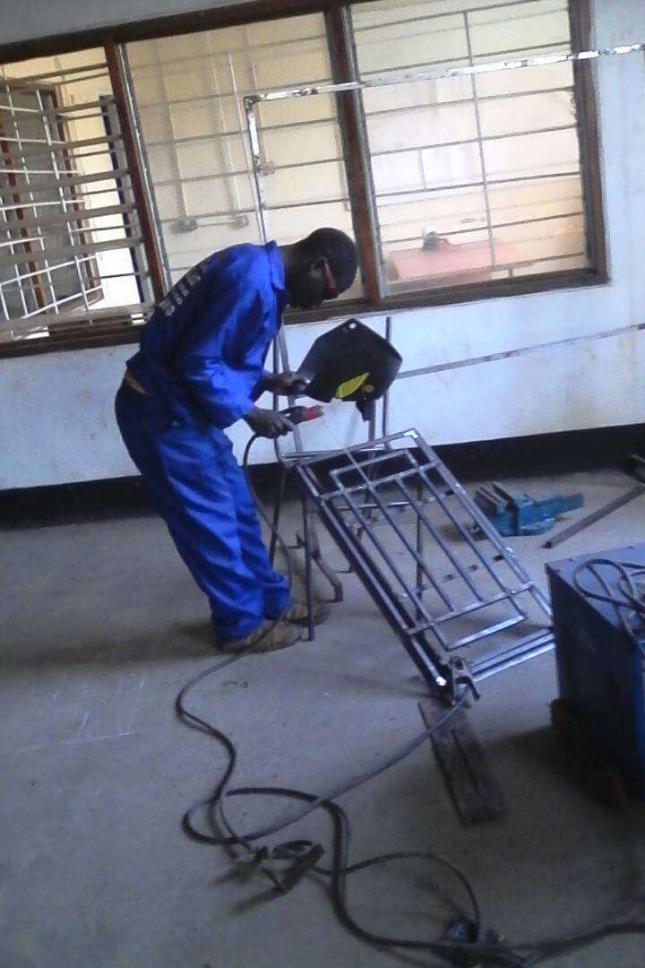
13 youth (9 boys and 4 girls) were trained in various technical fields for 3 months and after the completion of the intensive training they were given some equipment’s for a start. Out of 13 youth, 2 boys trained in carpentry and joinery, 1 girl was doing plumbing, 2 girls and 2 boys were trained in design and tailoring. Finally, 1 girl and 5 boys were trained in welding and fabrications.
A separate meeting to provide the tools to youth was organized at Ntchisi Executive lodge and the Guest of honor for the function was the District Commissioner. This meeting organized in a special way like graduation function for the boys and girls who completed the short course in vocational skills. It was colorful event because we had lectures from Mponela technical community college, Government officials, Religious leaders from different churches, Parents and Guardians from different communities and some NGOs. In total the attendance of the day was about 100 people.

  - Project close out meeting with key stakeholders meeting at district level
The purpose of the meeting was to share the results of the project to the key stakeholders and at the same time to close the project officially. The similar meeting took place at the beginning of the project targeting the same key stakeholders for increased collaboration on the project. The key stakeholders included government officials and NGOs like save the children and Action aid to mention a few. This meeting took place at Ntchisi Executive Lodge and about 15 participants (9 males and 6 females) attended and after the meeting the final presentation copy of the project results was shared to all stakeholders present.
6.0 Sustainability
There is that high expectation of activities sustainability because youth are involved in Village Savings and Loans through self-selection criteria and trained in business management and entrepreneurship skills. Others were trained in vocational skills. In addition the project also provided loans as revolving fund and this will be there to continue in 2019 and reach more youth beneficiaries.
7.0 Achievements
The project registered key achievements within 12 months
- 200 youth (110 males and 90 females) trained in business management, VSL and entrepreneurship skills. (against the target of 120)
- 13 youth (9 males and 4 females) trained in different vocational skills (plumbing, Tailoring, Carpentry and Welding) and provide them with vocational tools. (against the target of 12)
- 60 youth (42 males and 18 females) received loans amounting to 2 million Malawi kwacha and started different small scale businesses. Eg barber shops, Groceries, Selling chips and Kanyenya.
- Youth managed to pay back MK2 million invested in different small businesses for 3-4 Months
- 6 Youth clubs supported with 6 balls for sporting activities
- 9 youth clubs out of 12 managed to save MK1, 752,000 within 3-4 months after VSL trainings
8.0 Lessons learnt
The youth economic project is one of the best projects for job creation among the youth especially in developing countries like Malawi. There is high demand searching for self-employment through small scale business and agriculture commercialization.

9.0 Challenges and proposed solutions
- The trainings days for Village savings, business and entrepreneurship skills was too short. The youth were trained for 3 days and it was cumbersome to cover all the topics. Such trainings are recommended for 10 days both theory and practical sessions. Therefore in future will plan well according to the standards as it is recommended by the government through District Community Development Office. If resources are available will conduct refresher trainings targeting the youth trained in 3 days to equip them more information that was not provided due to resources limitations.
- Youth training in various technical fields was done in three months. This was very short period for the students to grasp everything. The government recommendation for technical short courses in community colleges minimum is 6 months. From now onwards will make sure to adhere to the guidelines and recommendation given. However, to address the gap we have talked with the youth trained in vocational skills to discuss and work together with other local artisans in their communities to gain more practical skills before they are established on their own.
- In general, the resources for the project was inadequate considering that this was a pilot activity but the demand to benefit from such initiative is very high in Malawi and especially in Ntchisi district. NECOSS plans are underway to address the gap and the thinking is to share this report to different partners at all levels as one of resource mobilization strategy for continuity of the Job for youth initiative. We are also planning to submit concepts and proposals to development partners that have passion and interest to work with the youth and create job opportunities among the youth.
10.1 Success story
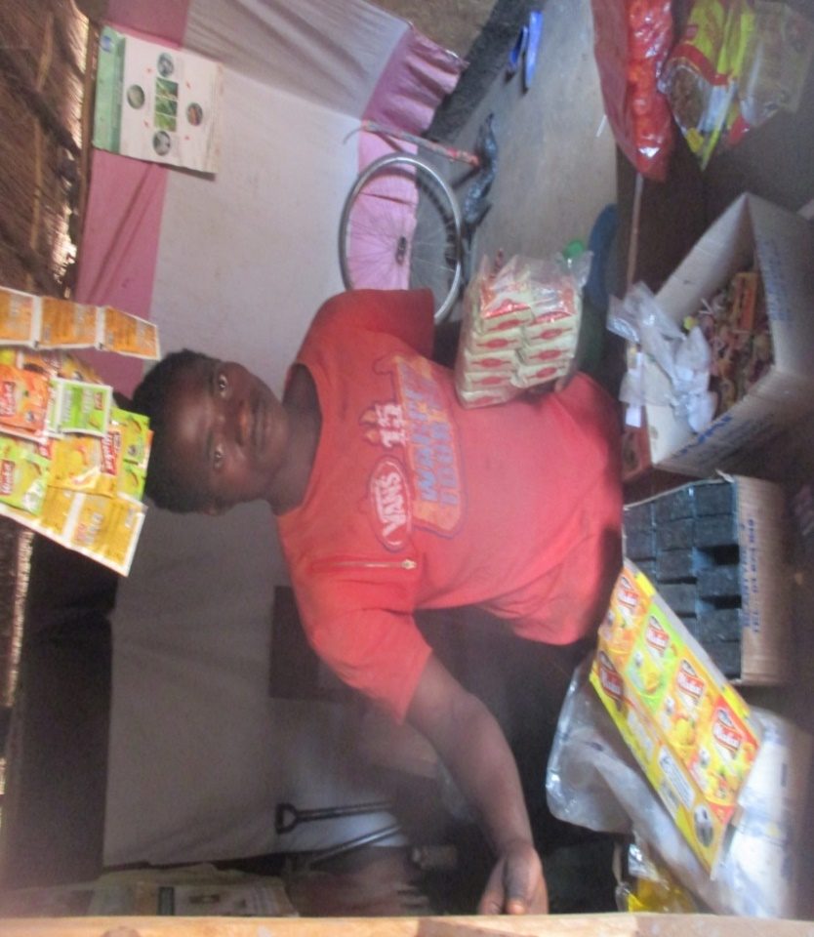
Albert aged 23 from Mpika village, T/A Vuso jere in Malawi is one of the youth benefited from the project through Mpika youth club. The boy’s life has changed than before because he is able to support herself on daily needs. Before the project life was tough and he thought there is nothing he can do considering that he is coming from the poor family. Thanks to the Project, things have changed and the past has gone am able to do things that was impossible before and my future is open.
10.2 success story
This is Zuze aged 29 years. He stays in Ntchisi district, Traditional Authority Vusojere, Nyanga village in Malawi. He belongs to Chitenje youth club and benefited a lot from the project through soft loan program. Zuze invested the moneys in Irish potato farming. Before the project he was struggling to get farm inputs mainly organic fertilizers and quality potato seed due to limited moneys. Thanks to project, now am able to swim in moneys. I got K50,000 Malawi Kwacha loan and this was enough to purchase all the necessary inputs in Irish potato farming. Am proud of this project because after harvest and have managed to get about K180,000 Malawi kwacha profit after 4 months only. I have paid back the loan and am remaining with something bigger in my pocket to proceed with my life in Irish Potato farming said Zuze. Let me share with you that in Malawi, Irish potato do well in Ntchisi district and its one of potential crop for commercial farming. It takes 3-4 months to mature and harvest. It’s very good in nutrition value, marketable but the youth lack resources especially moneys to purchase farming inputs and invest in commercial farming. Zuze has started well.
